Ideation Phase
Empathize & Discover

Date | 31 January 2025
Team ID: __________ | SAYS  “I want accurate weather information for my location.”  “I need an alert when heavy rain or severe weather is expected.”  “I want the forecast to be simple and easy to understand.”
Project Name: AI WeatherWise | THINKS  “Will the weather change suddenly?” “Can I trust this forecast before planning my day?”  “I need timely information rather than complicated weather data.”
Maximum Marks | 4 Marks

Empathy Map Canvas: An empathy map is a simple, easy-to-digest visual that captures knowledge about a user’s behaviours and attitudes.

It is a useful tool that helps the AI WeatherWise team better understand users who depend on weather forecasts and alerts.
Creating an effective solution requires understanding the true problem and the person who is experiencing it. The exercise of creating the map helps participants consider things from the user’s perspective along with his or her goals and challenges.
Example: AI WeatherWise User
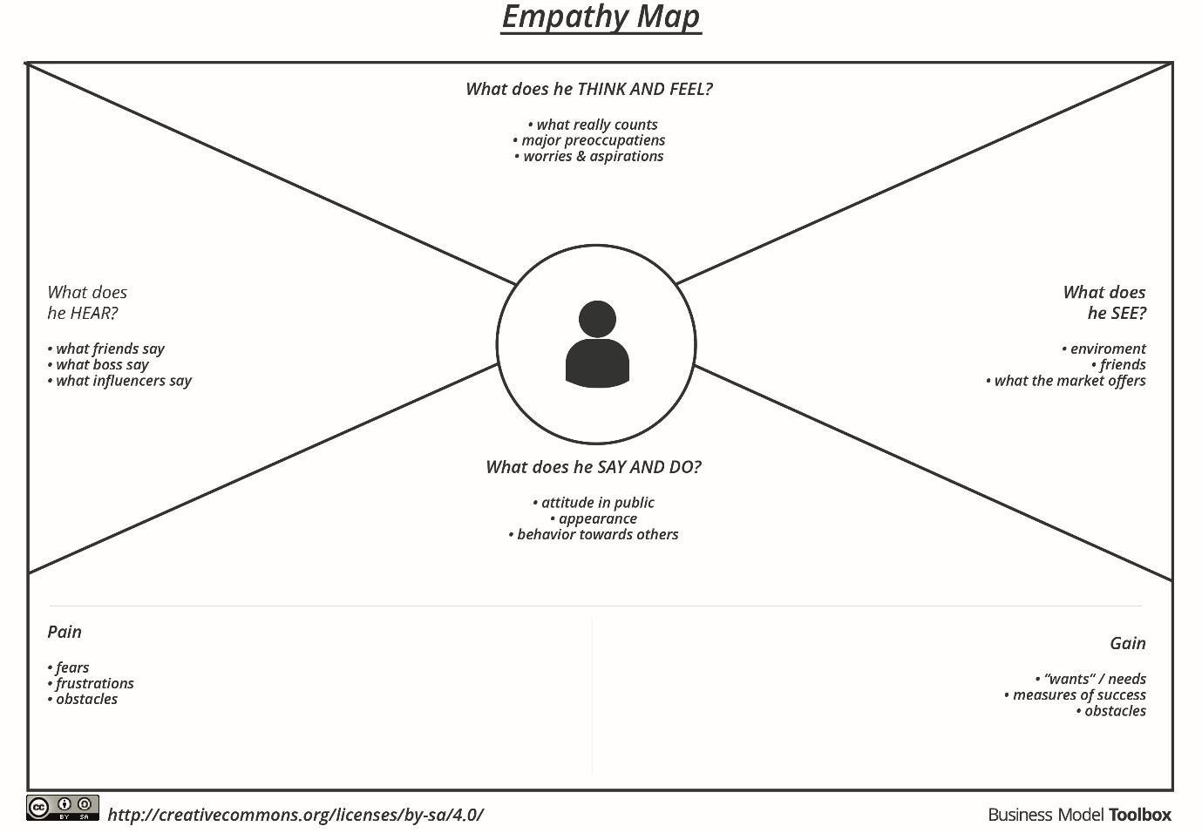
Project Focus: Understanding user needs for AI-based weather forecasting, alerts, and recommendations.

Example: AI WeatherWise – Weather Forecasting & Alert Application


